Name:_________________________________
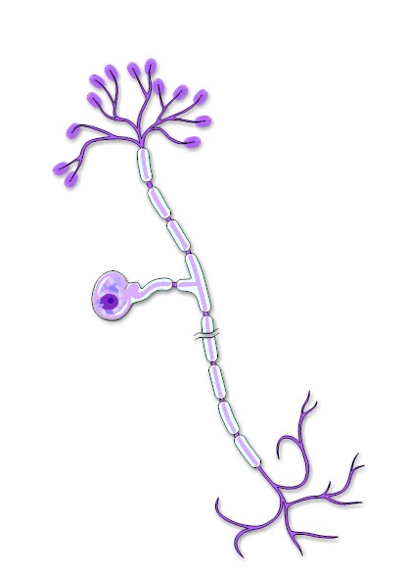
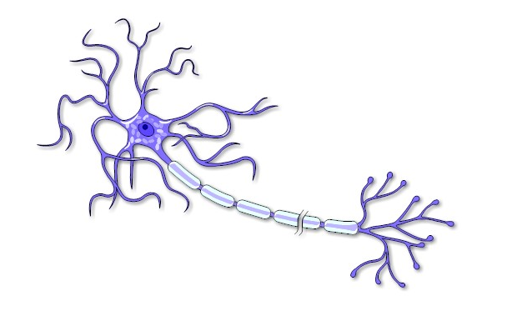
Shown below is a motor neuron and a sensory neuron. Identify and label each one. Describe the differences you see between the two.

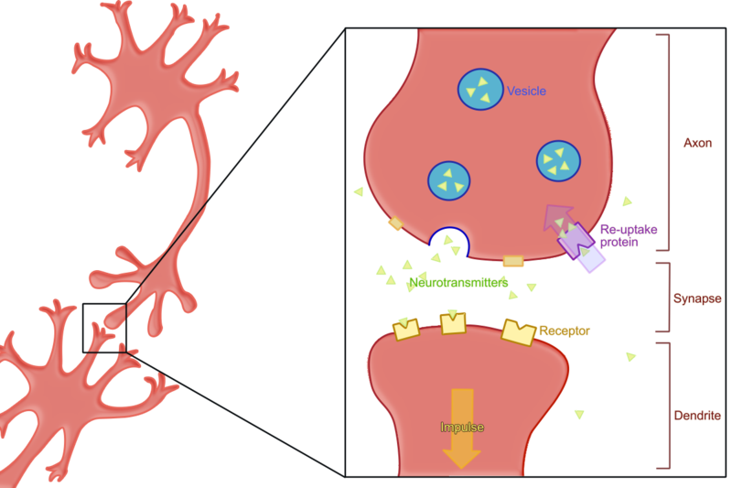
Shown are two neurons and a synapse. Label each neuron and write a definition for synapse.
Impulse

